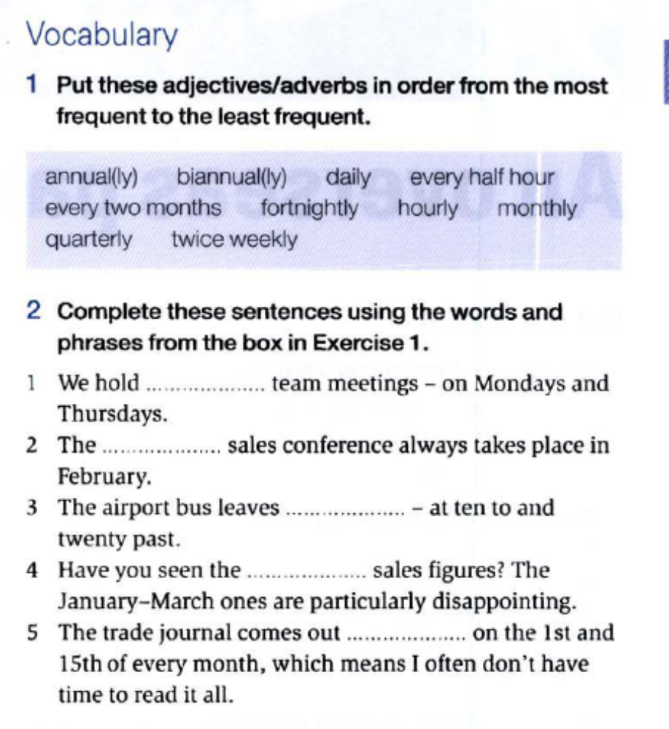
Twice weekly
Annual
Every half hour
Every two monts
Fortnightly
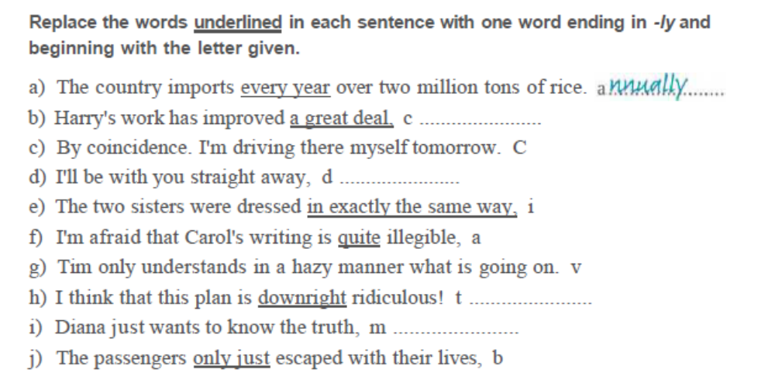
b) Considerably/massively/significantly
c) coincidently
d) directly/shortly
e) identically
f) apparently
g) vaquely
h) totally
i) merely
j) barely
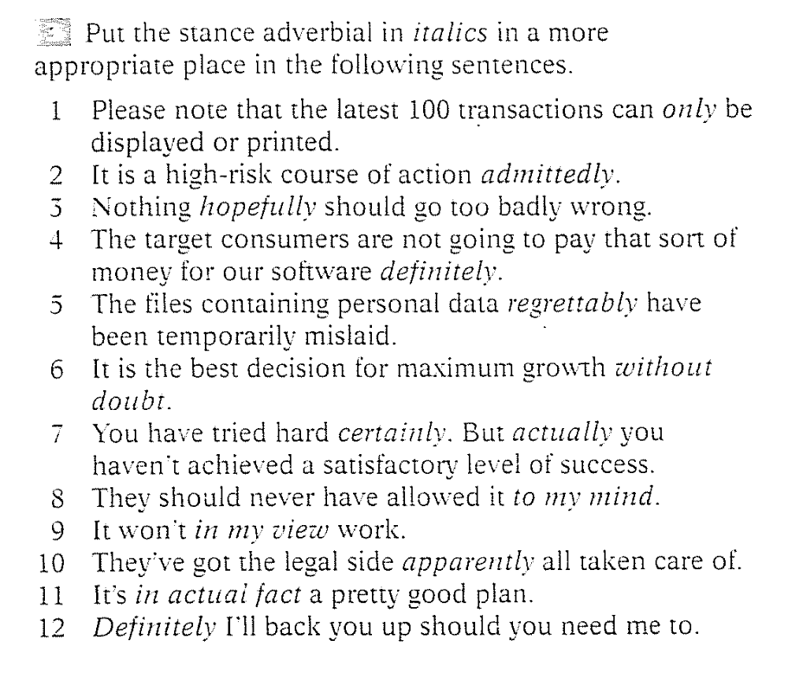
- Be only
- Is admittedly
- Hopefully
- Are definitely
- Regrettably
- Without doubt
- You have certainly, Buy you actually
- To my mind
- In my view
- Got apparently
- In actual fact
- Definitely
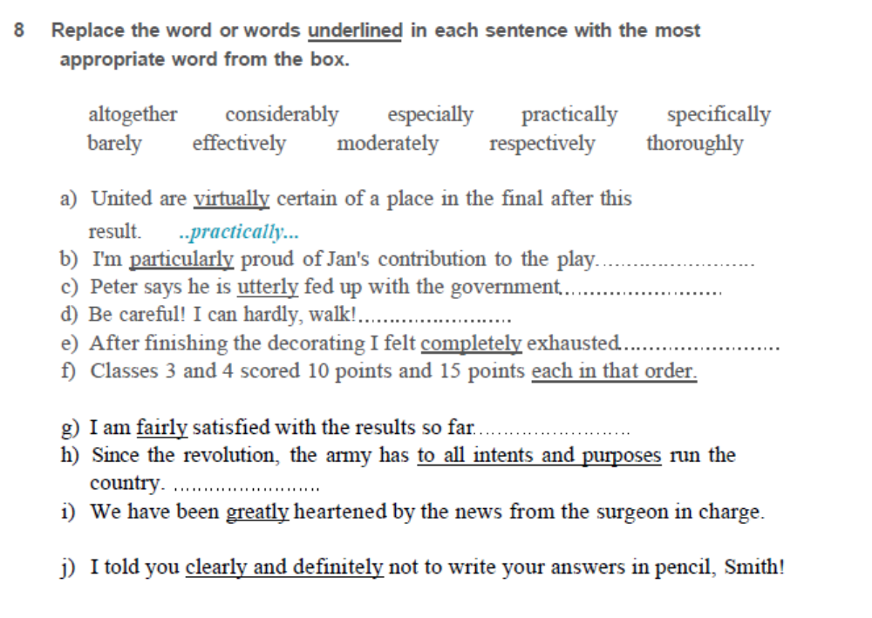

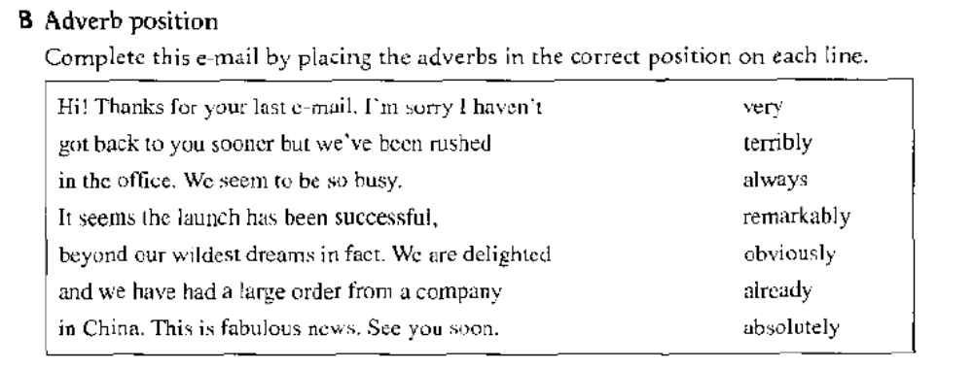
Very thanks
Terribly rushed
We always
Remarkably succesful
We are obviously
We have already had
Absolutely fabulous
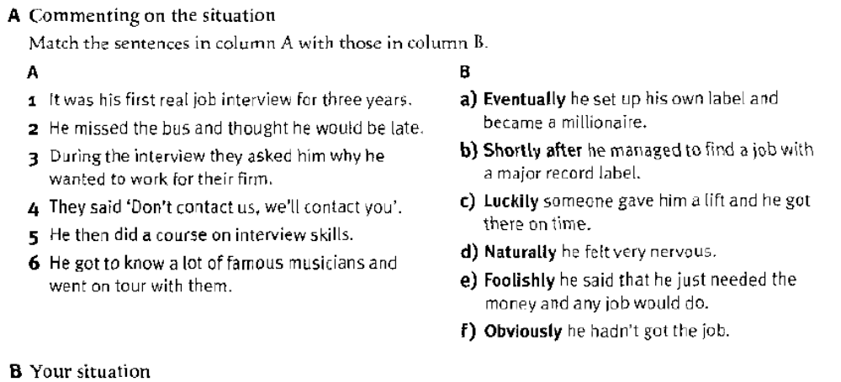
1. f
2. c
3. e
4. b
5. a
6. d
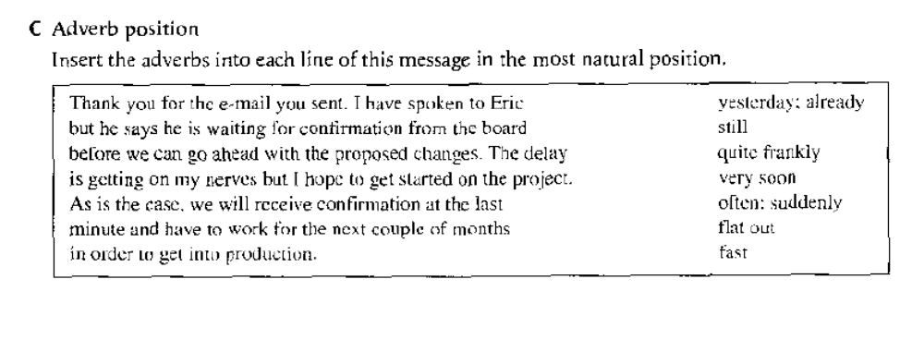
Sent yesterday, I have already spoken
He is still waiting
Changes quite frankly
Ve
As is oftren, we will suddenly
F
In fast order

